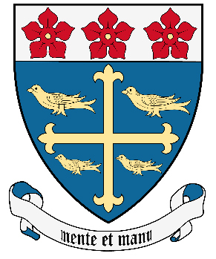
Queensferry High School

Communications Policy

(Last Updated Aug 2023)

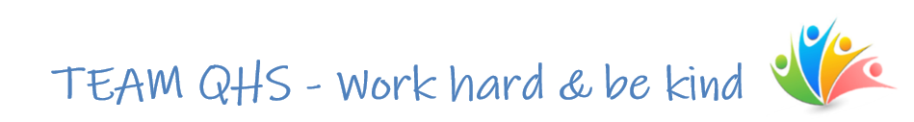
How we keep in touch

We keep our school community up to date in the following ways:

Phone – the school phone number is 0131 319 3200 and we will call you to follow up on any unexplained absences from school or when a member of staff wishes to talk with you. If possible please save our number in your contacts so we do not show up as an ‘unknown call’ on your phone. Some staff have school mobiles as part of their role and may use these to call you.

GroupCall Text Messages – text messages are used to send out urgent important information for example, if your child absent from school and you haven’t contacted us, school closures or important school notices.

Class Charts – you can download this from the app store, search for Class Charts for Parents. The school office can support to provide your login details. All updates throughout the year will be through the announcements function, sitting alongside the information on your young persons’ progress and engagement.

School Email – email is used to contact you with information such as our reports, parent/carer night information, trip details or subject information.

Website – our website www.queensferryhigh.co.uk is updated regularly and contains documents and information our community may need as well as news and information about the school.

Twitter – we have a twitter account @QueensferryHS which is used to share news and interesting information with our wider community. We welcome contributions to this which can be sent into our school email account admin@queensferry.edin.sch.uk.

There are also several faculty and department Twitter accounts which are used to share additional information (e.g., sporting fixtures) and also celebrate the success of our pupils.

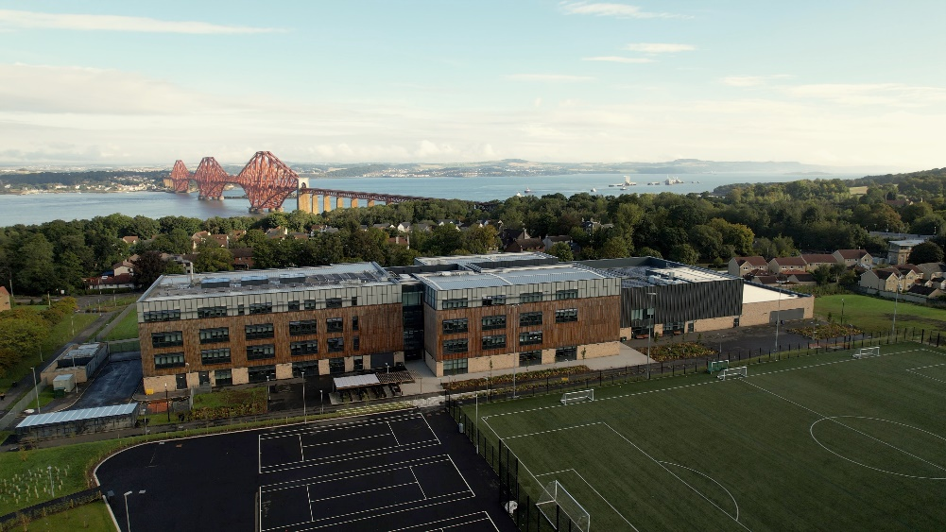

How you can contact us

You can contact us by emailing admin@queensferry.edin.sch.uk or phoning the school office on 0131 319 3200. We will then direct your enquiry to the appropriate member of staff.

Please note all our staff have fixed commitments throughout the day such as meetings and classes therefore they may not be able to get back to you immediately.

We aim to resolve your enquiry within 5 working days.

Senior Leadership Team
You can contact our Headteacher and Depute Headteachers through the School Office (0131 319 3200) or by emailing our admin account admin@queensferry.edin.sch.uk. While we always welcome your enquiries please note we may pass this on to another member of staff if we feel this issue is best resolved by them. We aim to resolve your enquiry within 5 working days.

Pastoral Support(Guidance) Enquiries
You can contact our Pupil Support Leaders though the email addresses below, through the School Office (0131 319 3200) or by emailing our admin account admin@queensferry.edin.sch.uk. We aim to resolve your enquiry within 5 working days.

- Dundas – Susan Lamb – Susan.Lamb@queensferry.edin.sch.uk
- Forth – Jocelyn Hannah – Jocelyn.Hannah@queensferry.edin.sch.uk
- Hopetoun – Kevin Thomas – Kevin.Thomas@queensferry.edin.sch.uk
- Rosebery – Christina MacNeil – Christina.MacNeil@queensferry.edin.sch.uk

Support for Learning
Our Support for Learning department can be contacted through the School Office (0131 319 3200) or by emailing our admin account admin@queensferry.edin.sch.uk. We have a number of staff who work in this faculty and this will allow us to direct your enquiry to the most appropriate person.

Subject Enquires
We ask that you do not email your child’s teacher. Please direct all enquires through the School Office (0131 319 3200) or by emailing our admin account admin@queensferry.edin.sch.uk. Your enquiry will then be directed to the appropriate person. This is because staff have very little administration time to deal with enquiries and we want to make sure someone can help you within an adequate timescale. We aim to resolve your enquiry within 5 working days.

Please note if a teacher has contacted you directly to discuss your child then you do not need to go through the admin account to reply.

